Bangladesh Medical Association (BMA)
List of Life Member-31
67. BMA Thakurgaon Branch

Sl No | Voter No | Voter Details
1 | Voter No  LM-6700001  No Image | DR. MD. SHAMSUL ALAM CHOWDHURY  F/Name:  M/Name:  BM & DC Reg. No:  NID:  Cell:  Address:  Blood Group:  TRANSFERED to BMA Dhaka City  LM-1405543
2 | Voter No  LM-6700002  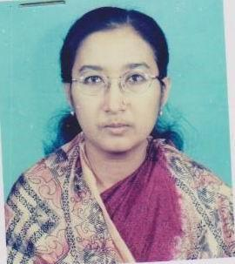 | DR. NASIMA AKHTAR JAHAN  F/Name: Md. Nayeb Ali Miya  M/Name:  BM & DC Reg. No:  NID:  Cell:  Address:  Blood Group:
3 | Voter No  LM-6700003 | DR. ABU MOHD. KHAIRUL KABIR  F/Name: Late Abdur Rouf  M/Name:  BM & DC Reg. No:  NID:  Cell:  Address: Vill. Kalibari, P.O. Thakuragaon  Thakurgaon  Blood Group:
4 | Voter No  LM-6700004 | DR. MD. MIRAJUL ISLAM  F/Name: Late. Khademul Islam Chowdhury  M/Name: Shamsun Nahar  BM & DC Reg. No: 20795  NID:  Cell: 01715412010  Address: Shaheed Titumir Sarak, Kalibari, P.O & Dist: Takurgaon-5100  Blood Group: A+
5 | Voter No  LM-6700005  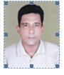 | DR. ABUL BASAR MD. HAMIDUR RAHMAN  F/Name: Md. Taaizuddin  M/Name:  BM & DC Reg. No:  NID:  Cell:  Address: Vill. Hajipara,  Thakurgaon.  Blood Group:
6 | Voter No  LM-6700006  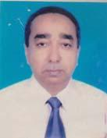 | DR. MD. RUHUL AMIN  F/Name: Late Gias Uddin Ahmed  M/Name: Late. Sunnatanesa  BM & DC Reg. No: 14554  NID:  Cell: 01917809511  Address: UHC Ranisankail, Thakurgaon.  Blood Group: B+
7 | Voter No  LM-6700007  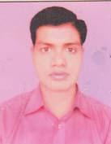 | DR. MD. REZAUL KARIM  F/Name: Ahammad Hossen  M/Name: Hosne Ara Begum  BM & DC Reg. No: 44097  NID: 9410842574919  Cell: 01712530029  Address: UHC, Haripur, Thakurgaon.  Blood Group: B+
8 | Voter No  LM-6700008  No Image | DR. MD. SHAHAJAHAN NEWAZ  F/Name:  M/Name:  BM & DC Reg. No:  NID:  Cell:  Address: Junior Consultant (Paediatric)  Adhunic Sadar Hospital, Thakurgaon  Blood Group:
9 | Voter No  LM-6700009  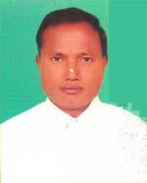 | DR. DHIRENDRA NATH ROY  F/Name: Baidya Nath Roy  M/Name: Fani Roy  BM & DC Reg. No: 15377  NID: 9429403111838  Cell: 01718691303  Address: Santi Nagar Thakurgaon  Blood Group: A+
10 | Voter No  LM-6700010 | DR. NAHIDA ISALAM  F/Name: Dr. Md. Nazrul Islam  M/Name: Mrs. Ismat Ara Islam  BM & DC Reg. No: 66104  NID: 9418679672166  Cell: 01737211168  Address: Vill+Post-Nekmard, Upazila-Rauisonkail, Dist-Thakurgaon  Blood Group: B+
11 | Voter No  LM-6700011 | DR. SHUVENDU KUMAR DEBNATH  F/Name: Late Sudhir Chandra Debnath  M/Name: Late Namita Debnath  BM & DC Reg. No: 23059  NID: 6826302110885  Cell: 01819804719  Address: Sardar Hospital, Thakurgaon  Blood Group: A+
12 | Voter No  LM-6700012  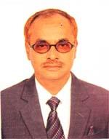 | DR. MD. ABUL KASHEM  F/Name: Late Saifuddin Ahammed  M/Name: Late Ayesha Khatun  BM & DC Reg. No: 14761  NID: 9429405121155  Cell: 01712481749  Address: Hagipara, Thakurgaon  Blood Group: A+
13 | Voter No  LM-6700013  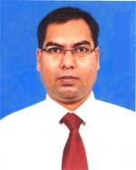 | DR. MD. TOZAMMEL HAQUE  F/Name: Md. Belayet Ali  M/Name: Mrs. Lalmon Begum  BM & DC Reg. No: 31828  NID: 8524904052876  Cell: 01712269835  Address: CDC. B.B. ROAD. THAKURGAON  Blood Group: B+
14 | Voter No  LM-6700014  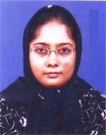 | DR. MST. ROKEYA SATTER  F/Name: Md. Abdus Satter  M/Name: Mrs. Ambia Khanam  BM & DC Reg. No: 41155  NID: 8524904052893  Cell: 01716617845  Address: CDC, BB Road, Thakurgaon  Blood Group: B+
15 | Voter No  LM-6700015 | DR. MD. ZILLUR RAHMAN SIDDQUE  F/Name: Reazuddin Ahmed  M/Name: Jahanara Begum  BM & DC Reg. No: 23470  NID: 8524902016532  Cell: 01741662611  Address: C.D.C Bangobandhu Sadar Thakurgaon  Blood Group: A+
16 | Voter No  LM-6700016  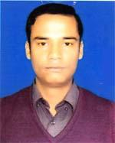 | DR. MD. FIROZ ALAM  F/Name: Late Nazrul Islam  M/Name: Mrs. Jakia Sultana  BM & DC Reg. No: 51894  NID: 9429402110162  Cell: 01727989288  Address: Doctors Quater, UHC, Ranisankoil, Thakurgaon  Blood Group: B+
17 | Voter No  LM-6700017  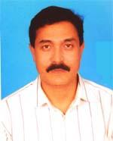 | DR. MD. NADIRUL AZIZ  F/Name: Late Dr. Aziz Uddin Ahmed  M/Name: Mrs. Noor Jahan Ahmed  BM & DC Reg. No: 20599  NID: 2695041750846  Cell: 07722327516  Address: Uhfpo, Sadar, Thakurgaon  Blood Group: B+
18 | Voter No  LM-6700018  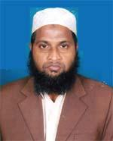 | DR. SHEIKH MASUD  F/Name: Sheikh Abdul Mazid  M/Name: Most. Asia Begum  BM & DC Reg. No: 36522  NID: 9429404114869  Cell: 01712162227  Address: Noresh Chouhan road, Goshpara, Thakurgaon-5100  Blood Group: O+
19 | Voter No  LM-6700019  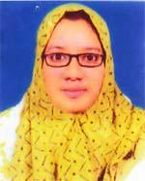 | DR. TOHFA QURAISHI  F/Name: Late Dr. S. A. Qader Quraishi  M/Name: Dr. Nazwa Begum  BM & DC Reg. No: 67998  NID: 9429406126796  Cell: 01719131164  Address: Shahid Md. Ali Road, Tantipara, Thakurgaon  Blood Group: B+
20 | Voter No  LM-6700020  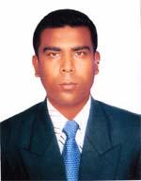 | DR. MD. ABUL KASAM  F/Name: Md. Pashir Uddin  M/Name: Late Amena Khatun  BM & DC Reg. No: 44694  NID: 19807521003629058  Cell: 01717727012  Address: Doctors Quarter, Upazila Health Complex, Baliadangi, Thakurgaon.  Blood Group: B+
21 | Voter No  LM-6700021  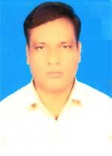 | DR. RANJIT KUMAR ROY  F/Name: Late Dinabandhu Roy  M/Name: Late Sabitri Rani  BM & DC Reg. No: 47936  NID: 7713485517136  Cell: 01718234725  Address: Vill-Shantinagar, Thakurgaon Sadar Thakurgaon  Blood Group: B+
22 | Voter No  LM-6700022  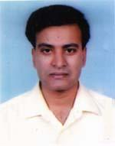 | DR. MD. REZAUL KARIM  F/Name: Md. Abdul Majid  M/Name: Mrs. Hasmot Ara Begum  BM & DC Reg. No: 35044  NID: 2697557395514  Cell: 01819122106  Address: Consultant Cardiology Adunik Sador Hospital, Thakurgaon  Blood Group: O+
23 | Voter No  LM-6700023 | DR. KHADIZA  F/Name: Md. Abul Hossain Sikder  M/Name: Mrs. Nurjahan Begum  BM & DC Reg. No: 41763  NID: 2696829710285  Cell: 01920819992  Address: Medical officer, Salondor Union Health Mub Center, Sador, Thakurgaon  Blood Group: AB+
24 | Voter No  LM-6700024  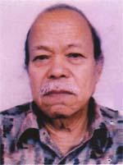 | DR. KSHIRODE CHANDRA BARMAN  F/Name: Mohan Chandra Barman  M/Name: Monsori Barman  BM & DC Reg. No: 3551  NID:  Cell: 01917126278  Address: Kali Bari, Thakurgaon  Blood Group: O+
25 | Voter No  LM-6700025  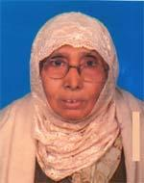 | DR.HAZERA AKHTAR  F/Name: Eusuf- Al-haider (eusuf)  M/Name: Khatemoon Nesa  BM & DC Reg. No: 3572  NID: 9429405118677  Cell: 01716707526  Address: Kakoli, Ahzipara, Thakurgaon  Blood Group: B+
26 | Voter No  LM-6700026 | DR. SHIHAB MAHMUD SHAHRIAR  F/Name: Late. Sayedur Rahman  M/Name: Sayeda Begum  BM & DC Reg. No: 44057  NID: 2695046971521  Cell: 01714569602  Address: Kalibari, Thakurgaon, Municipalty, Thakurgaon  Blood Group: O+
27 | Voter No  LM-6700027  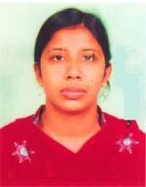 | DR. SMIRTY HAQUE  F/Name: Dr. Md. Shahidul Haque  M/Name: Nasima Parvin  BM & DC Reg. No: 43928  NID: 2695046971520  Cell: 01710604549  Address: Islambag-Tikapara-Thakurgaon  Blood Group: B+
28 | Voter No  LM-6700028 | DR. MD. OBAIDUL HAQUE  F/Name: Late Dr. Nazir Hossain Khandker  M/Name: Late Afroza Begum  BM & DC Reg. No: 45264  NID: 2695045905993  Cell: 01819213422  Address: Hazipara. Thakurgaon  Blood Group: A+
29 | Voter No  LM-6700029  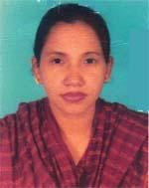 | DR. MST. SHIRIN AKHTER  F/Name: Md. Abdur Razzak  M/Name: Mst. Aziza Kahtun  BM & DC Reg. No: 39747  NID: 19789419413437197  Cell: 01712933126  Address: Medical officer (Disease Control) Cwil Surgeon office Thakurgaon  Blood Group: B+
30 | Voter No  LM-6700030  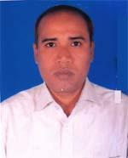 | DR. MD. SAZZAD HAIDER SHAHIN  F/Name: Md. Ruhul Amin Sarker  M/Name: Mst. Nurun Nehar  BM & DC Reg. No: 34442  NID: 7712529415073  Cell: 01716187087  Address: Jr. Consultant (Paed) Ashunic Sadar Hospital, Thakurgaon  Blood Group: O+
31 | Voter No  LM-6700031  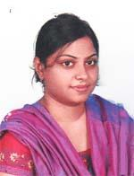 | DR. TABASSUM KABIR  F/Name: Dr. Abu Mohammad Khairul Kabir  M/Name: Shamsun Nahar Begum  BM & DC Reg. No: 75462  NID: 19909429406000022  Cell: 01868084378  Address: Sonali Swapna, Flat No. A8, House No. 27/2/C, Road No. 3, Shyamoli, Dhaka.  Blood Group: n_a

